Creating Teams through cloud design box

Login to cloud design box Cloud Design Box (cdbadmin-prod.azurewebsites.net)
- Select sites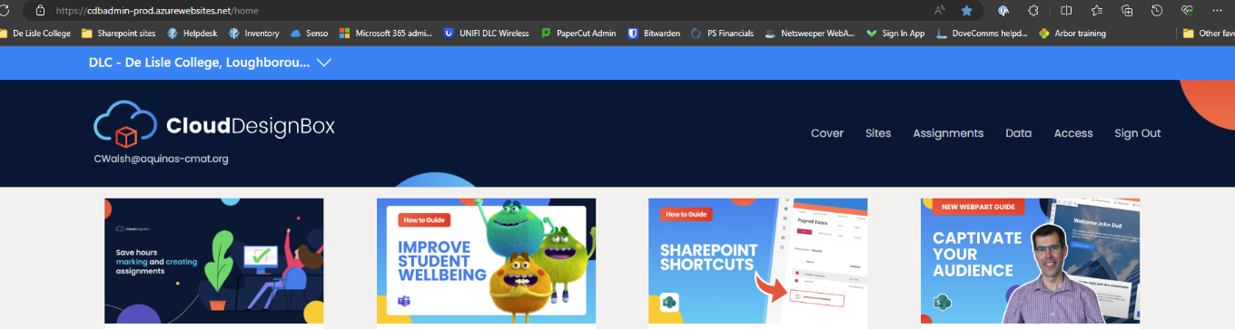
- Select team site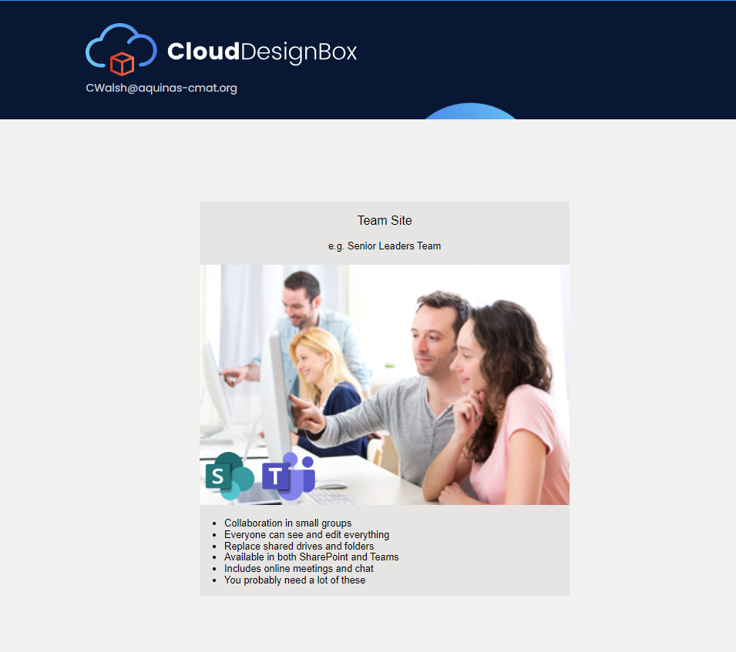
- Fill in the details for the team you wish to create. For team sites, fill in the form. You can define individuals as owner or members of the team. 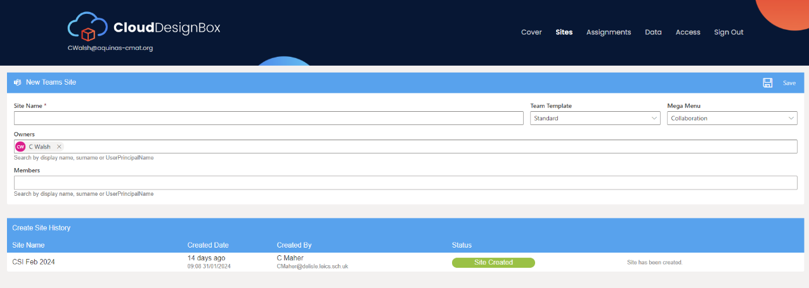
- Your own account will automatically appear in the owners list which can be removed if needed.
- For external teams members these will need to be added after the team is created
- Press save when this is done. Please note it will take a few minutes to create the team.

